**25Q3 MANUAL AUDIT PeopleHub**

**Information Disclosure Co-Workers Tab**

### Introduction:

The test applications that are owned by Zalaris are actively tested for vulnerability using manual Penetration test

# 

Table of Contents

Introduction: 2

2025 Q3 Manual Audit PeopleHub Information Disclosure in Co-Workers Tab 4

### 2025 Q3 Manual Audit PeopleHub Information Disclosure in Co-Workers Tab

**Description**

Manual Test is done against PeopleHub CoWorkers Tab

**Steps**

Here is the normal request in Co-workers tab

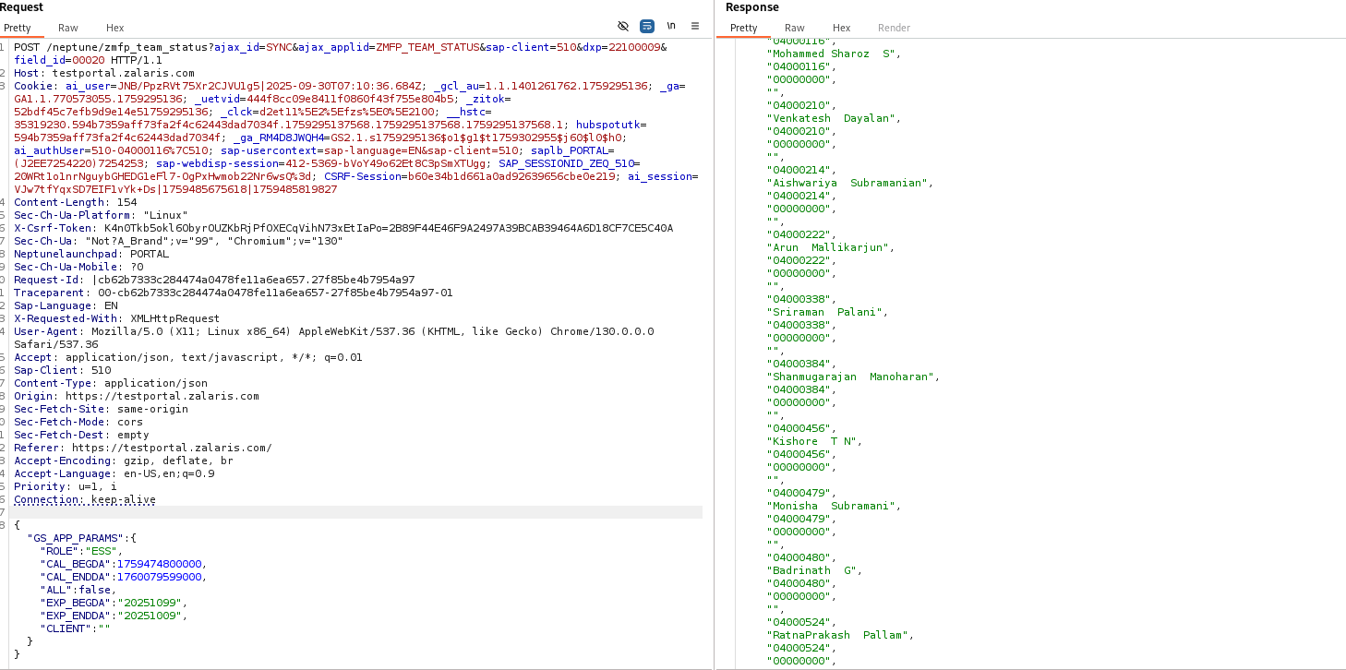

Injecting the ROLE Parameter with arbitrary values resulted in the following information disclosed to the user in the response

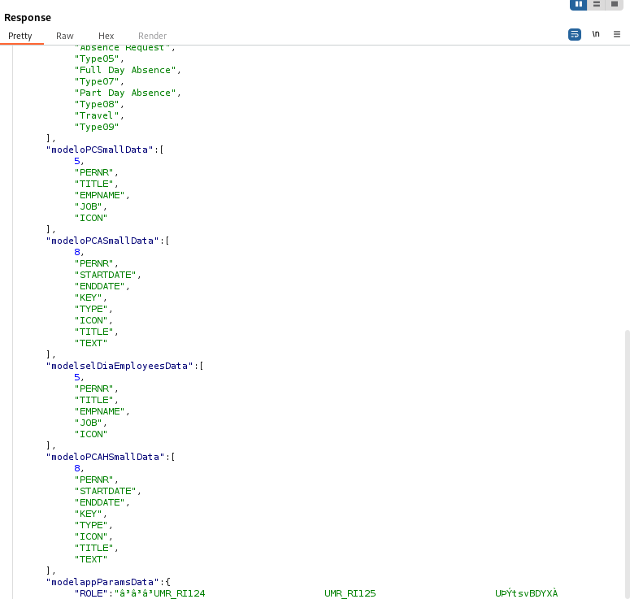

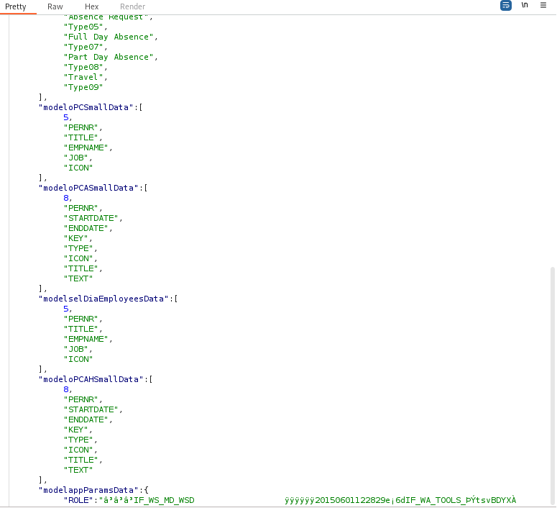

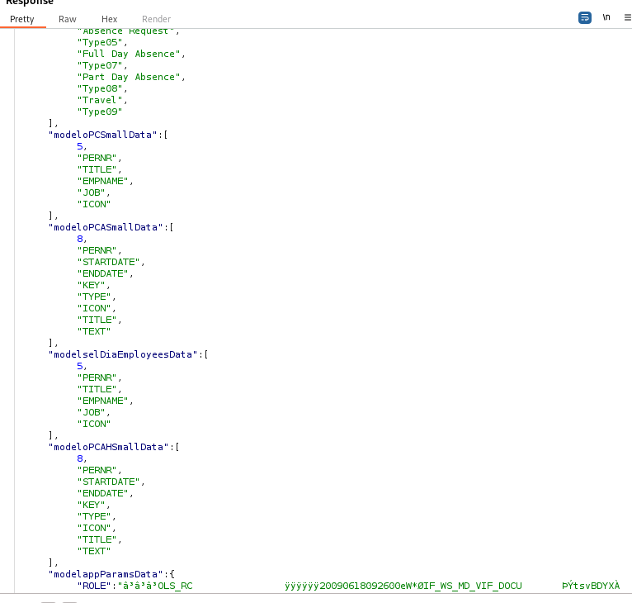

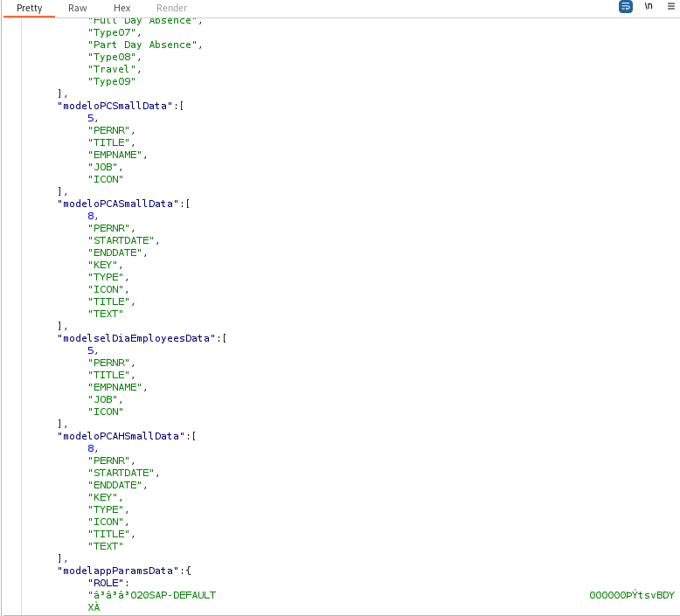

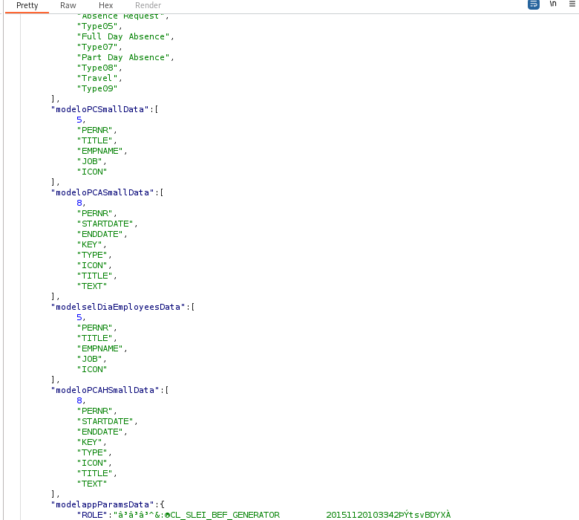

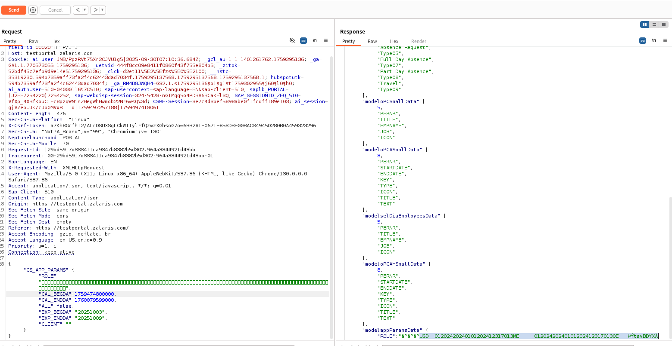

**ResponseCoWorkers14**

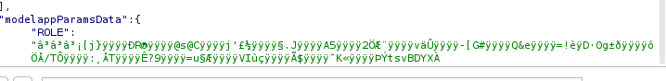

**ResponseCoWorkers16**

**WORKLOG**

|  |  |  |  |  |
| --- | --- | --- | --- | --- |
| When | What | Who | Inference | Action plan |
| 03 September 2025 | Manually tested the co-worker tab Information Disclosure Vulnerability is found | Mohammed Sharoz | Proper input validation is not set in the back-end | Further test in |